Profile Section Redesign: Profile-based Filter Functionality

Andrew L. Sandler

11/20/2000

Background:
In the current version of Allegis Sales Partner (A|SP 4.5), the Profile S1 allows the Vendor to see a wealth of information about a given Partner. Included in this view is a set of tertiary navigation elements that are almost identical to the S1, S2 arrangement of the primary navigation.
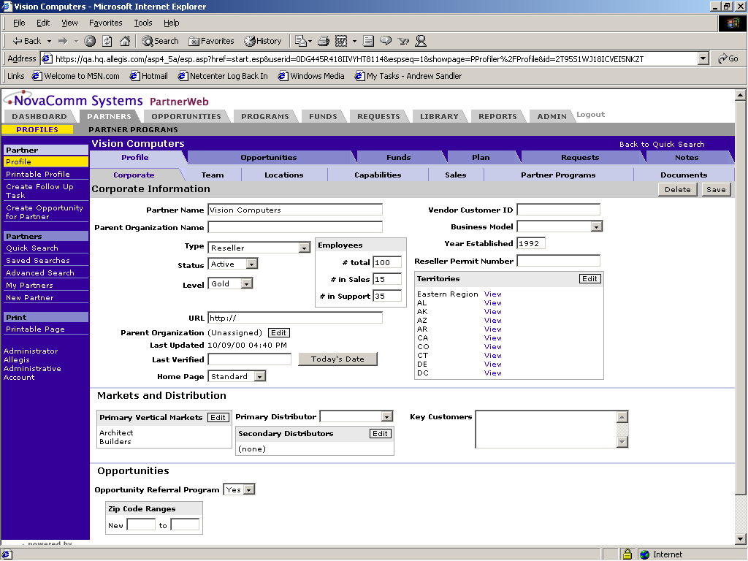
. In accordance with the new Portalization effort underway for the SQUID release, these tabs can no longer exist in their present form. The removal of the tabs may have the additional benefit of removing a source of confusion to user who may not understand that the “Opportunities”, “Funds”, and “Plan” tabs are filtered views of the information in the S1 tabs.

Solutions:
Any solution will have to have two components. The first is the ability to view non-profile partner information from the “Partners” tab (i.e. Opportunities as they relate to the specific partner from within the “Partners” tab). The second is the ability to drill down in specific categories to find relevant partner information (i.e. Opportunities as they relate to the specific partner from within the “Opportunities” tab).
This proposal will be addressing the first component.

Recommendation:

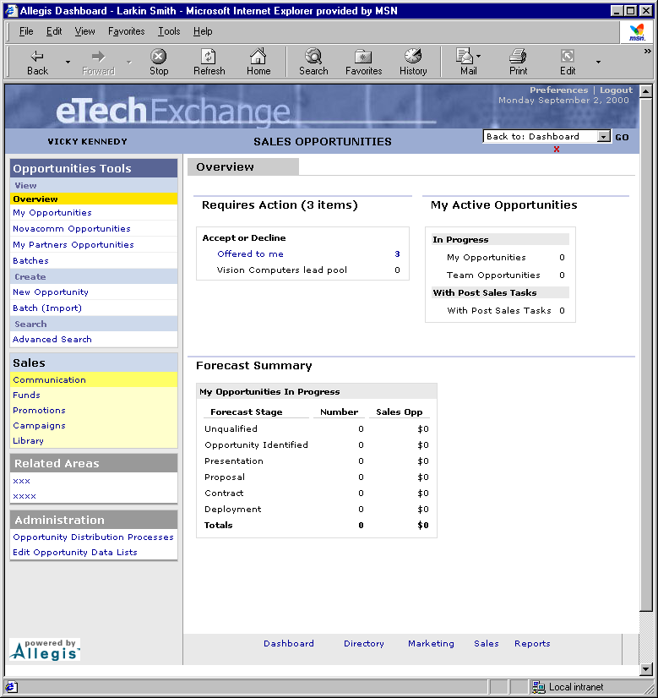

- (Green Box) In order to maintain consistency in the interface, the side navigation items should fall under the Portalization design of “Create”, “Search” and “View”. Within the “View” section should be links to “This Partner’s Opportunities”, “This Partner’s Funds”, “This Partner’s Plan”, etc. There is the possibility of using the Partner’s name instead, as in “Vision Computers’ Funds”, but seeing as the Partner’s name is a string of variable length, it is not the optimal solution.
- (Red Box) Add the links to the new navigation pull down and/or site map. There may be an interesting way to add the links to the “Back to:” pull down or in a separate section of the site map. This may cause issues with the consistency of the navigation tools, as the links could be different based on Roles, Rights and Partner types.

Other Considerations:
- There could be a more generic way to filter information based on a particular Company or partner. We could design a two step wizard that allows the user to select the type of information in one step and select the relevant target in the second step. This wizard could be linked off every “View” section. It would allow a large amount of reuse and would be consistent for everyone. The disadvantage is that it would introduce an additional step into a relatively straightforward process.
- We could allow the users to get their information through the “Advanced Search” functionality already in the program. It requires additional coding for the search tool. The disadvantage is that it eliminates functionality that already exists in the product by removing the association between the data and the Profile and adds a complex search process that may not be well understood.

